**Summary:**

The goal of this assignment was for the student to complete the missing pieces of a provided code to make the program work as intended. The purpose was to practice using functions and arrays to manage data and drive program direction. Also, the main() function is driven by a loop that begins the game and terminates when either player 1 or 2 wins. Functions are written to check for a valid player move, draw the game board, and confirm the winner. The function names are self explanatory and more information about them can be found in the code comments. Some errors I experienced include a lot of syntax error, which is understandable because part of the assignment was to fill in the missing pieces of the code. Therefore, I discovered errors when I first loaded the program and compiled it. Another reason I compiled the program before editing it was to determine where the errors were occuring. Each test case is displayed below as well as the program code on the final page.

**Test Case 1: Player 1 Wins**

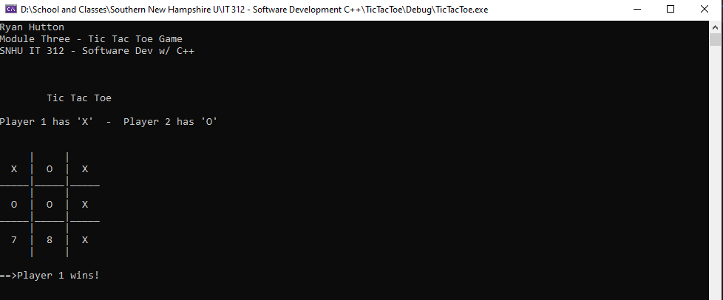

**Test Case 2: Player 2 Wins**

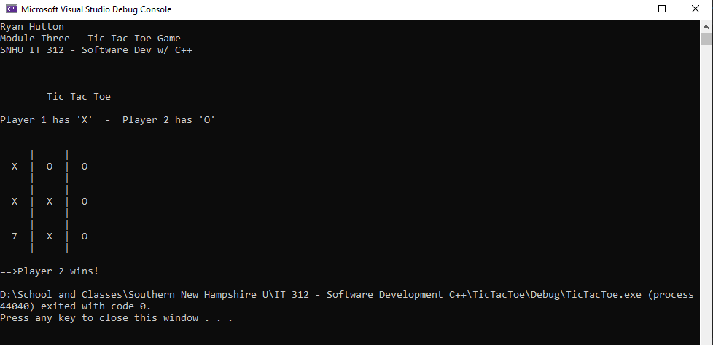

**Test Case 3: Game Draw**

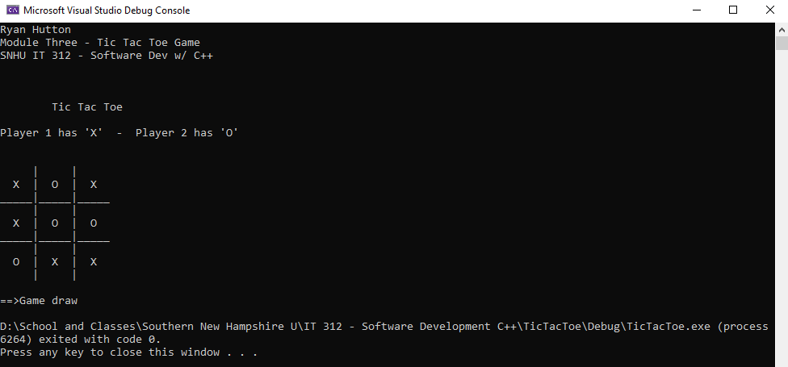

**Test Case 4: Invalid Move (Choice Outside of Board Range)**

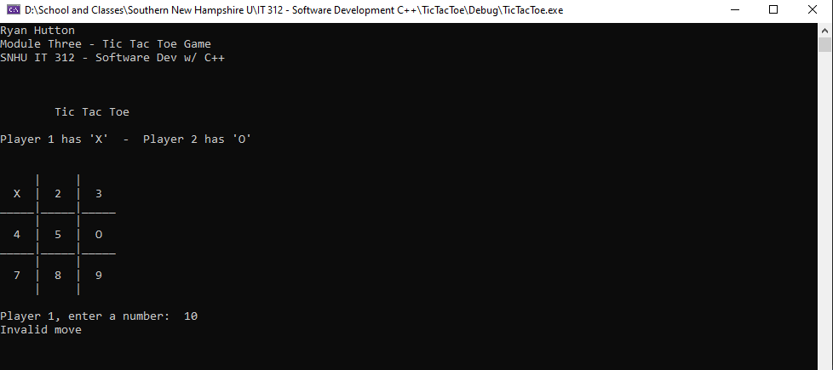

**Test Case 5: Invalid Move (Choice Already Selected)**

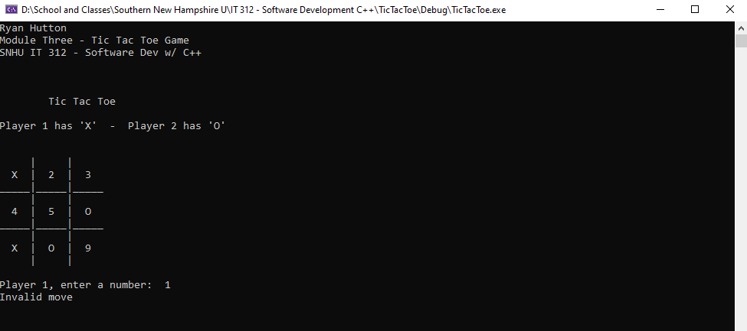

Code on last page.

